EE 316 Spring 2018, Nur Touba, 15320

1/26/2018

Donald Maze-England

Lab 1

**Problem 1:**

Gate implementation:

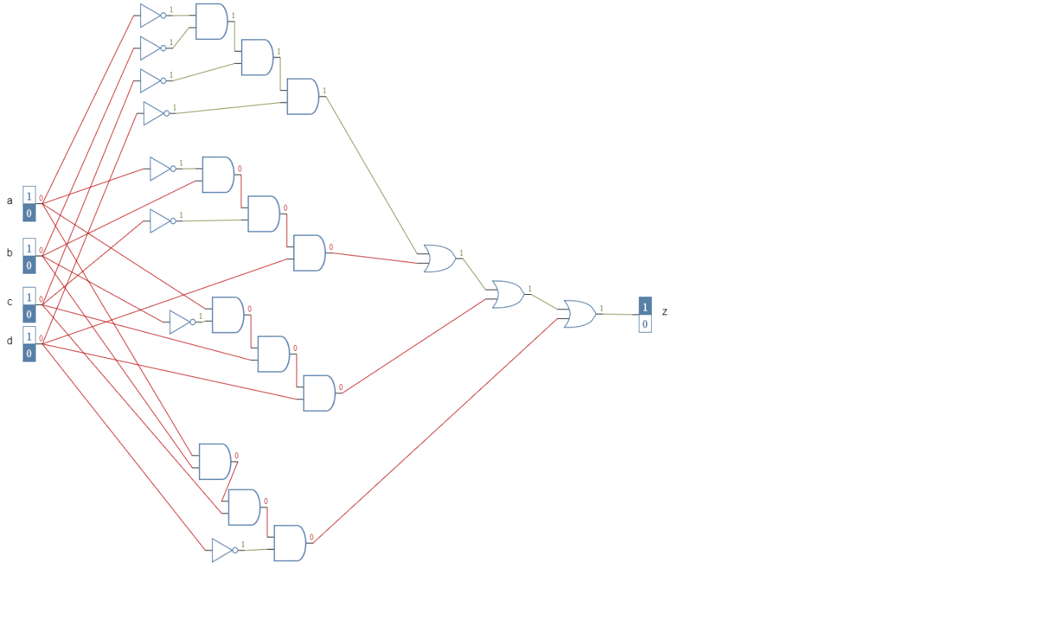

Truth table:

|  |  |  |  |  |  |  |  |  |
| --- | --- | --- | --- | --- | --- | --- | --- | --- |
| a | b | c | d | a’b’c’d’ | a’bc’d | ab’cd | abcd’ | Z1 |
| 0 | 0 | 0 | 0 | 1 | 0 | 0 | 0 | 1 |
| 0 | 0 | 0 | 1 | 0 | 0 | 0 | 0 | 0 |
| 0 | 0 | 1 | 0 | 0 | 0 | 0 | 0 | 0 |
| 0 | 0 | 1 | 1 | 0 | 0 | 0 | 0 | 0 |
| 0 | 1 | 0 | 0 | 0 | 0 | 0 | 0 | 0 |
| 0 | 1 | 0 | 1 | 0 | 1 | 0 | 0 | 1 |
| 0 | 1 | 1 | 0 | 0 | 0 | 0 | 0 | 0 |
| 0 | 1 | 1 | 1 | 0 | 0 | 0 | 0 | 0 |
| 1 | 0 | 0 | 0 | 0 | 0 | 0 | 0 | 0 |
| 1 | 0 | 0 | 1 | 0 | 0 | 0 | 0 | 0 |
| 1 | 0 | 1 | 0 | 0 | 0 | 0 | 0 | 0 |
| 1 | 0 | 1 | 1 | 0 | 0 | 1 | 0 | 1 |
| 1 | 1 | 0 | 0 | 0 | 0 | 0 | 0 | 0 |
| 1 | 1 | 0 | 1 | 0 | 0 | 0 | 0 | 0 |
| 1 | 1 | 1 | 0 | 0 | 0 | 0 | 1 | 1 |
| 1 | 1 | 1 | 1 | 0 | 0 | 0 | 0 | 0 |

The output for Z1 is HIGH only when a and c are LOW and b and d are either both HIGH or both LOW, or when a and c are HIGH and when only either b or d is HIGH.

**Problem 2:**

Gate Implementation:

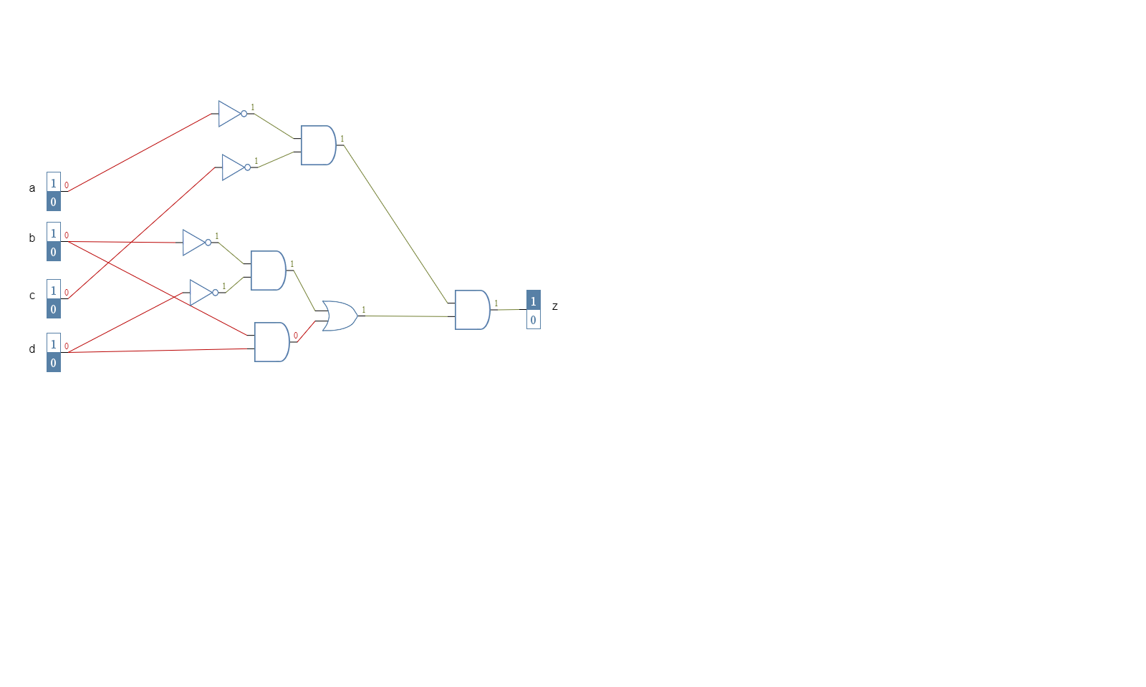

Truth Table:

|  |  |  |  |  |  |  |  |  |
| --- | --- | --- | --- | --- | --- | --- | --- | --- |
| a | b | c | d | a’c’ | b’d’ | bd | (b’d’+bd) | Z2 |
| 0 | 0 | 0 | 0 | 1 | 1 | 0 | 1 | 1 |
| 0 | 0 | 0 | 1 | 1 | 0 | 0 | 0 | 0 |
| 0 | 0 | 1 | 0 | 0 | 1 | 0 | 1 | 0 |
| 0 | 0 | 1 | 1 | 0 | 0 | 0 | 0 | 0 |
| 0 | 1 | 0 | 0 | 1 | 0 | 0 | 0 | 0 |
| 0 | 1 | 0 | 1 | 1 | 0 | 1 | 1 | 1 |
| 0 | 1 | 1 | 0 | 0 | 0 | 0 | 0 | 0 |
| 0 | 1 | 1 | 1 | 0 | 0 | 1 | 1 | 0 |
| 1 | 0 | 0 | 0 | 0 | 1 | 0 | 1 | 0 |
| 1 | 0 | 0 | 1 | 0 | 0 | 0 | 0 | 0 |
| 1 | 0 | 1 | 0 | 0 | 1 | 0 | 1 | 0 |
| 1 | 0 | 1 | 1 | 0 | 0 | 0 | 0 | 0 |
| 1 | 1 | 0 | 0 | 0 | 0 | 0 | 0 | 0 |
| 1 | 1 | 0 | 1 | 0 | 0 | 1 | 1 | 0 |
| 1 | 1 | 1 | 0 | 0 | 0 | 0 | 0 | 0 |
| 1 | 1 | 1 | 1 | 0 | 0 | 1 | 1 | 0 |

The output for Z2 is HIGH only when a and c are both LOW and either b and d are both LOW or b and d are both HIGH.

**Problem 3:**

Gate Implementation:

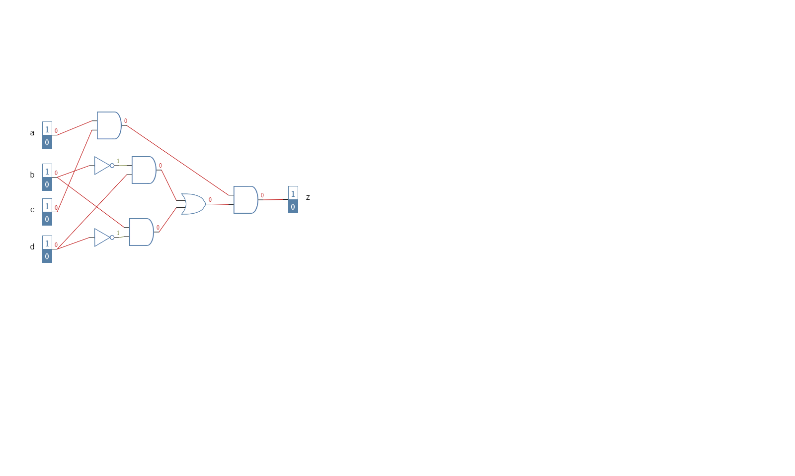

Truth Table:

|  |  |  |  |  |  |  |  |  |
| --- | --- | --- | --- | --- | --- | --- | --- | --- |
| a | b | c | d | bd’ | b’d | bd’+b’d | ac | Z3 |
| 0 | 0 | 0 | 0 | 0 | 0 | 0 | 0 | 0 |
| 0 | 0 | 0 | 1 | 0 | 1 | 1 | 0 | 0 |
| 0 | 0 | 1 | 0 | 0 | 0 | 0 | 0 | 0 |
| 0 | 0 | 1 | 1 | 0 | 1 | 1 | 0 | 0 |
| 0 | 1 | 0 | 0 | 1 | 0 | 1 | 0 | 0 |
| 0 | 1 | 0 | 1 | 0 | 0 | 0 | 0 | 0 |
| 0 | 1 | 1 | 0 | 1 | 0 | 1 | 0 | 0 |
| 0 | 1 | 1 | 1 | 0 | 0 | 0 | 0 | 0 |
| 1 | 0 | 0 | 0 | 0 | 0 | 0 | 0 | 0 |
| 1 | 0 | 0 | 1 | 0 | 1 | 1 | 0 | 0 |
| 1 | 0 | 1 | 0 | 0 | 0 | 0 | 1 | 0 |
| 1 | 0 | 1 | 1 | 0 | 1 | 1 | 1 | 1 |
| 1 | 1 | 0 | 0 | 1 | 0 | 1 | 0 | 0 |
| 1 | 1 | 0 | 1 | 0 | 0 | 0 | 0 | 0 |
| 1 | 1 | 1 | 0 | 1 | 0 | 1 | 1 | 1 |
| 1 | 1 | 1 | 1 | 0 | 0 | 0 | 1 | 0 |

The output for Z3 is HIGH only when both a and c are HIGH and only 1 of either b or d is HIGH.

**Problem 4:**

Gate Implementation:

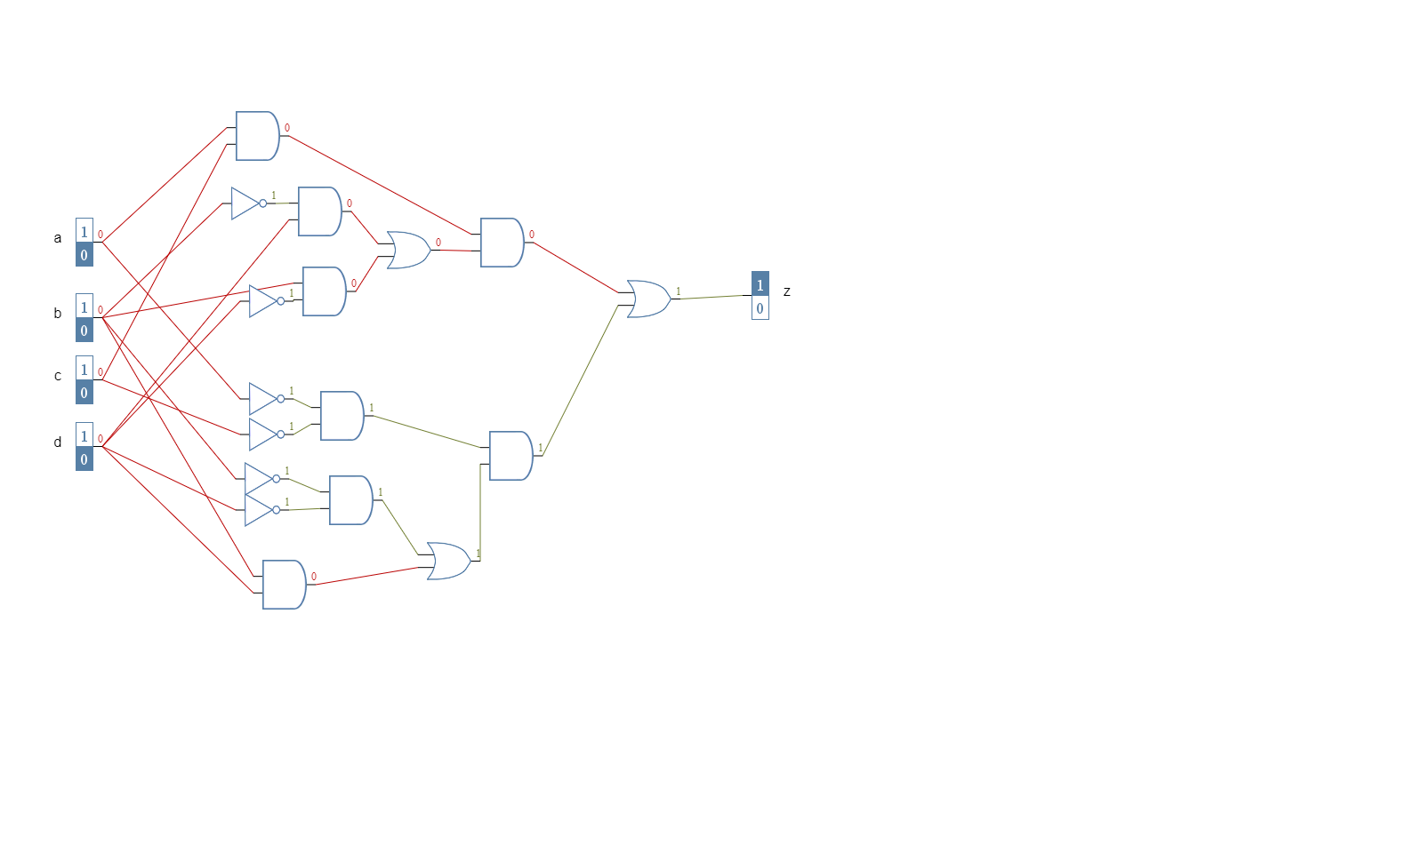

Truth Table:

|  |  |  |  |  |  |  |
| --- | --- | --- | --- | --- | --- | --- |
| a | b | c | d | Z2 | Z3 | Z2+Z3 =Z4 |
| 0 | 0 | 0 | 0 | 1 | 0 | 1 |
| 0 | 0 | 0 | 1 | 0 | 0 | 0 |
| 0 | 0 | 1 | 0 | 0 | 0 | 0 |
| 0 | 0 | 1 | 1 | 0 | 0 | 0 |
| 0 | 1 | 0 | 0 | 0 | 0 | 0 |
| 0 | 1 | 0 | 1 | 1 | 0 | 1 |
| 0 | 1 | 1 | 0 | 0 | 0 | 0 |
| 0 | 1 | 1 | 1 | 0 | 0 | 0 |
| 1 | 0 | 0 | 0 | 0 | 0 | 0 |
| 1 | 0 | 0 | 1 | 0 | 0 | 0 |
| 1 | 0 | 1 | 0 | 0 | 0 | 0 |
| 1 | 0 | 1 | 1 | 0 | 1 | 1 |
| 1 | 1 | 0 | 0 | 0 | 0 | 0 |
| 1 | 1 | 0 | 1 | 0 | 0 | 0 |
| 1 | 1 | 1 | 0 | 0 | 1 | 1 |
| 1 | 1 | 1 | 1 | 0 | 0 | 0 |

The output for Z4 is HIGH only when if a and c are both LOW and b and d are either both HIGH or LOW, or if a and c are both HIGH and only one of either b or d is HIGH.

**Problem 5:**

Z1 is equal to Z4 for all possible input values.

**Problem 6:**

Screen shot of circuit in Viviado:

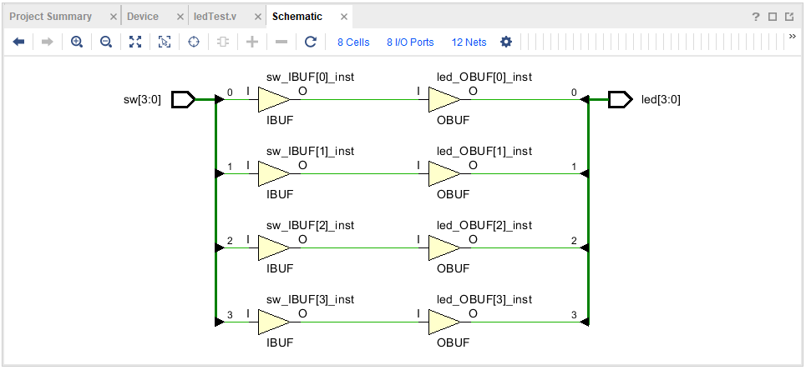

Pin Assignments:

|  |  |  |  |
| --- | --- | --- | --- |
| Inputs | Package Pin | Outputs | Package Pin |
| sw[0] | U15 | led[0] | U14 |
| sw[1] | W14 | led[1] | V14 |
| sw[2] | W13 | led[2] | V13 |
| sw[3] | W15 | led[3] | U16 |